Приложение № 9 към [**чл. 19, ал. 3**](http://10.20.162.80/Document/DocumentHighlighted?dbId=0&documentId=2137236859&searchedText=%D1%84%D0%B8%D1%81%D0%BA%D0%B0%D0%BB%D0%B5%D0%BD%20%D0%BA%D0%BE%D0%BD%D1%82%D1%80%D0%BE%D0%BB%20%D0%B2%D1%8A%D1%80%D1%85%D1%83%20%D0%B4%D0%B2%D0%B8%D0%B6%D0%B5%D0%BD%D0%B8%D0%B5%D1%82%D0%BE%20%D0%BD%D0%B0%20%D1%81%D1%82%D0%BE%D0%BA%D0%B8%20%D1%81%20%D0%B2%D0%B8%D1%81%D0%BE%D0%BA%20%D1%84%D0%B8%D1%81%D0%BA%D0%B0%D0%BB%D0%B5%D0%BD%20%D1%80%D0%B8%D1%81%D0%BA&edition=2147483647&iconId=1&stateObject=%7b%22kind%22:%22getSearchResults%22,%22page%22:1,%22navigateTo%22:%22/AllProducts%22,%22sortAsc%22:%22desc%22,%22sortCol%22:%22Score%22%7d&stateObject=%7b%22kind%22:%22getSearchResults%22,%22page%22:1,%22navigateTo%22:%22/AllProducts%22,%22sortAsc%22:%22desc%22,%22sortCol%22:%22Score%22%7d&stateObject=%7b%22kind%22:%22getSearchResults%22,%22page%22:1,%22navigateTo%22:%22/AllProducts%22,%22sortAsc%22:%22desc%22,%22sortCol%22:%22Score%22%7d)

**Предварително деклариране на превоз, преминаващ през Република България**

[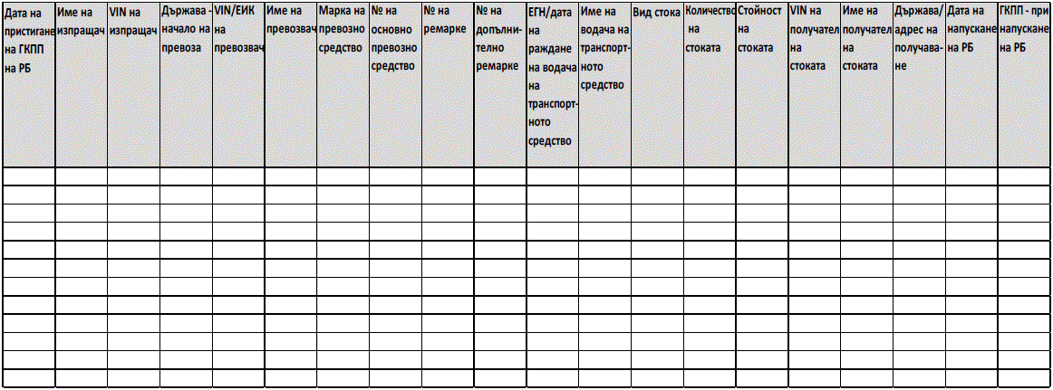](http://10.20.162.80/Content/Images/Document/80_1950143184_dv2023_br83_str56.gif)